Week1 Revisit

1. HTML
2. CSS
3. JS
4. NodeJS (JS Runtime Environment) – It enables run js code outside the browser.
5. Keywords, functions, operators, statements, arrow functions, for in, for of, Promises, Fetch(), variable hoisting, template String/Template literals, let, const keyword, es6 features
6. DOM Manipulation, DOM methods getElementById(), getElementsByName(), getElementsByTagName()
7. Document.write(), prompt(), alert()
8. JSON (JavaScript Object Notation)
9. AJAX (Asynchronous Javascript And XML)

Week2 Agenda

Typescript

React Introduction

WebPack (Bundling Tool)

CDN – Content Delivery Network

React Component Intro

Types of Component (Class based and functional components)

Lifecycle methods

Rendering Data

Communicate between components

Virtual DOM

JSX syntax (JS with HTML)

Props and State

Events Handling

Conditional Rendering

Hooks

Styling components

Routing using Axios

Axios VS Fetch()

useEffect Hook

Redux (Managing state of react app using Redux)

Flux Design Pattern

Redux (Reducers, Slicers, selectors)

Action dispatchers

State mapping

Testing React application using JEST framework

Day6 Agenda

1. TypeScript
2. WebPack
3. React Intro

TypeScript – Is typed superset of JavaScript (Strongly typed language)

Typescript is developed by Microsoft

Typescript syntax are similar to javascript.

Typescript can be transpiled to javascript

Transpilation = Translation + Compilation

Translation = (English to German, French to English) Converting one form of human speaking lang to other form of human speaking lang.

Compilation = process of converting human understandable programming language to machine understandable language(High Level Lang 🡪 Low level Lang)

Typesctipt ----tsc(typescript compiler)--🡪 javascript (transpilation)

Official URL of typescript

<https://www.typescriptlang.org/>

TypeScript is a strongly typed programming language that builds on JavaScript, giving you better tooling at any scale

<https://www.typescriptlang.org/play>

typescript = javascript + additional features

app.js 🡪 app.ts (Valid)

app.ts 🡪 app.js (Invalid) app.ts –tsc🡪 app.js (Valid)

All typescript file will have a .ts extension

Typescript checks the data type of variable at the compile time not at the runtime.

Compile time error checking – Is available in typescript

Npm = Node package manager (It’s a dependency Management tool for Javascript) (package.json)

Maven is a build and dependency management tool for JAVA (pom.xml)

Npm init (This utility will help you to create package.json file in interactive mode)

Npm installs the dependency in two ways

1. Local Installation (Available only in the downloaded folder) npm install typescript
2. Global Installation (Available for all locations) npm install -g typescript

Tsconfig – typescript configuration file

Npx tsc - -init (To create tsconfig.json file)

Global Installation Location --- C:\Users\<username>\AppData\Roaming\npm

Simple primitive Data types in Typescript

boolean (true/false)

number (0-9, OX, O, binary, real+imaginary (complex))

string , using “”, ‘’, `` (Multi line strings)

Assigning Data type to variable

1. Explicit (Adding data type at the time of creation/assigning value)

let firstName : string = “ABCD”;

1. Implicit (Just assigning the value without specifying data type) – Type will be detected automatically

let firstName = “XYZ”;

Special Data types

1. Any (this disables type checking – not recommended)
2. Undefined
3. Null
4. Never (rarely used data type, it throws error when a value is assigned to a variable)
5. Unknown (Safer alternative to any)

React JS – It’s a popular front end JS based library.

React is the product of Facebook.

React is a way to create dynamic Rich UI. (User Interface)

Official Site -- <https://reactjs.org/>

React is Declarative, Component Based, LOWA (Learn Once Write Anywhere)

React is a javascript based library used to create SPA web applications ( RWA – Responsive Web Applications)

SPA – Single Page Applications

Traditionally we create web sites using multiple web pages (inex.html, aboutus.html, contactus.html, services.html, login.html) [Multi Page Applications – MPA]

SPA – Only one page [index.html – logically divided into multiple components]

Component – Is a piece of UI which is generated with the help JS based library or framework.

Popular JS based library and framework available are

1. ReactJS (library)
2. Angular (Framework)
3. VueJS

Creating React App

1. Check node & npm version

Node -v

Npm -v

1. Create a react app using

Npx create-react-app my-app

Cd my-app

Npm start

1. 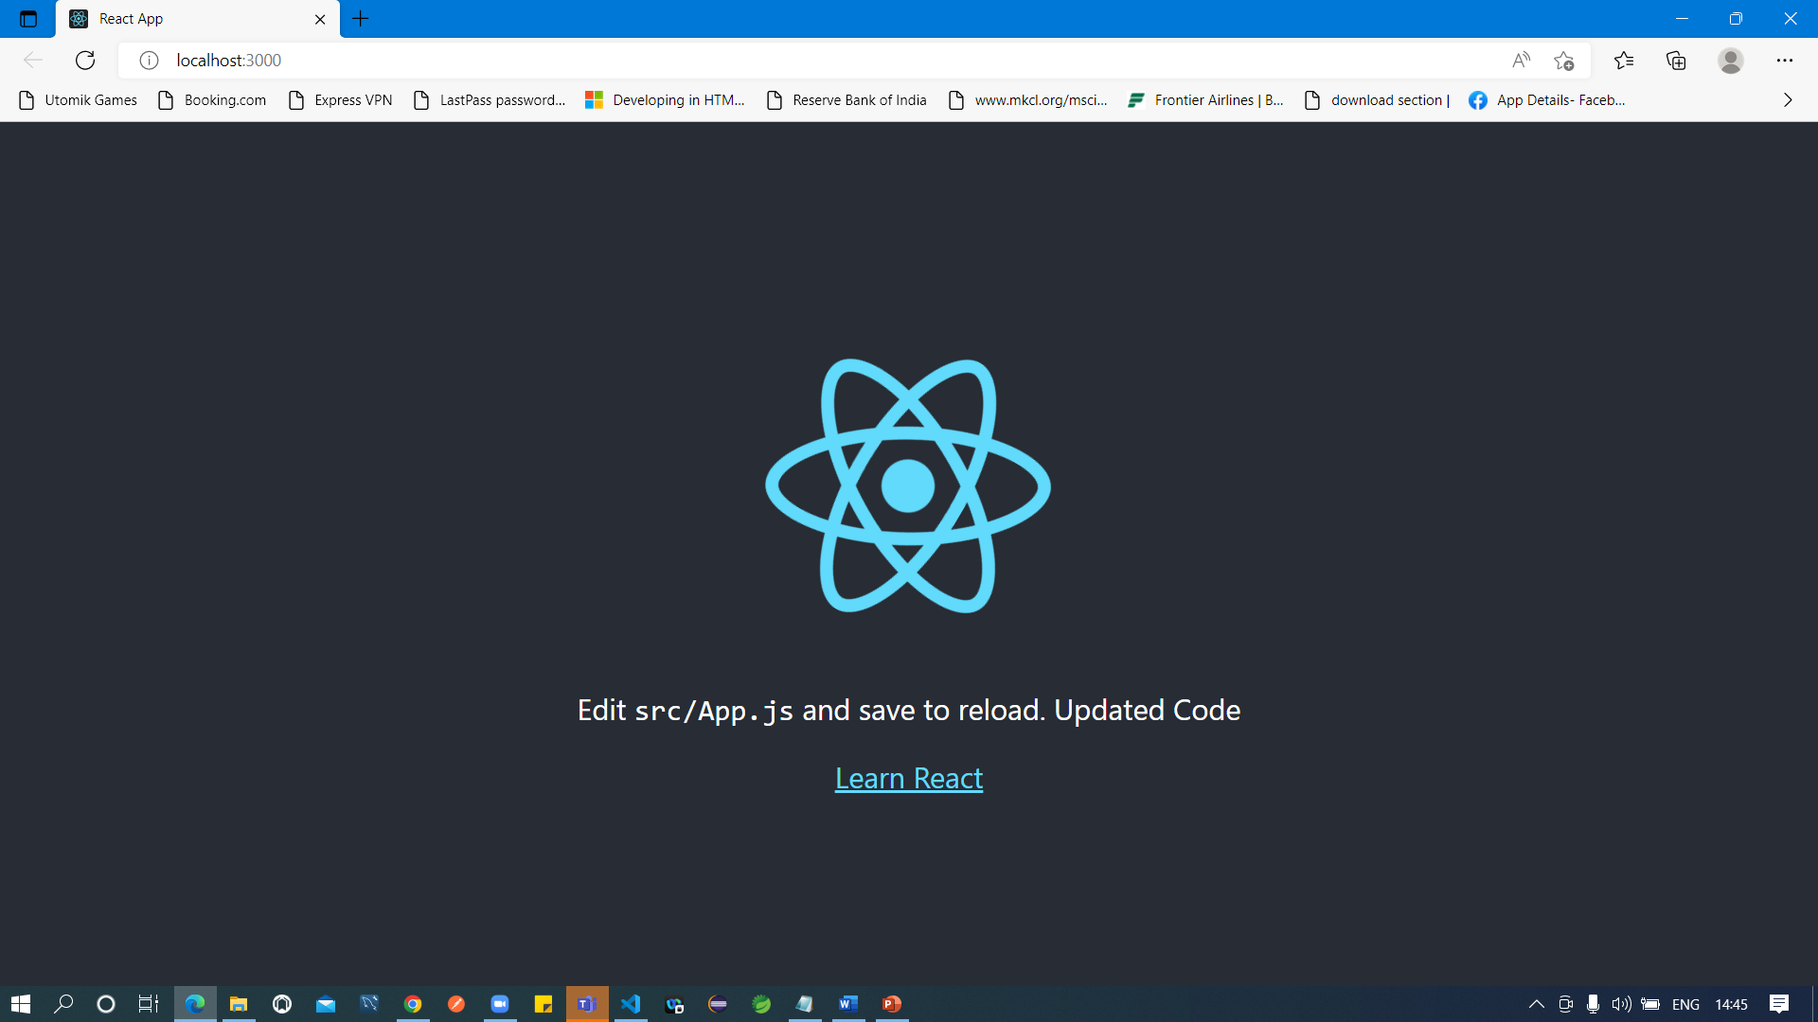

JSX = Syntax Extension to JavaScript (Few more features than JS)

Component is the way of creating custom HTML tag.

Components are re-usable piece of code (JS + HTML)

1. Class based Component (Stateful component)
2. Function based component (Stateless Component)